# Dashboard Deployment

1. Check the presence of dashboard in minikube’s addons:

$ minikube addons list

1. Enable (install) the kubernetes dashboard (Web UI) if it does not already:

$ minikube addons enable dashboard  
$ minikube addons enable metrics-server

1. Forward the port 8080 from host to access web UI inside cluster:

$ kubectl port-forward --address 0.0.0.0 --namespace kubernetes-dashboard svc/kubernetes-dashboard 8080:80

☝️ While working, port-forwarding blocks your console until you press Ctrl+C.

1. Open a browser and access it http://localhost:8080.
2. Stop port-forwarding by pressing Ctrl+C. Check whether do you still have connection or not.
3. You may leave or disable (delete) the dashboard service:

$ minikube addons disable dashboard

## Solution

1. Check the presence of dashboard in minikube’s addons:

$ minikube addons list  
|-----------------------------|----------|--------------|  
| ADDON NAME | PROFILE | STATUS |  
|-----------------------------|----------|--------------|  
| ambassador | minikube | disabled |  
| auto-pause | minikube | disabled |  
| csi-hostpath-driver | minikube | disabled |  
| dashboard | minikube | disabled |  
| default-storageclass | minikube | enabled ✅ |  
| efk | minikube | disabled |  
| freshpod | minikube | disabled |  
| gcp-auth | minikube | disabled |  
| gvisor | minikube | disabled |  
| helm-tiller | minikube | disabled |  
| ingress | minikube | disabled |  
| ingress-dns | minikube | disabled |  
| istio | minikube | disabled |  
| istio-provisioner | minikube | disabled |  
| kubevirt | minikube | disabled |  
| logviewer | minikube | disabled |  
| metallb | minikube | disabled |  
| metrics-server | minikube | disabled |  
| nvidia-driver-installer | minikube | disabled |  
| nvidia-gpu-device-plugin | minikube | disabled |  
| olm | minikube | disabled |  
| pod-security-policy | minikube | disabled |  
| registry | minikube | disabled |  
| registry-aliases | minikube | disabled |  
| registry-creds | minikube | disabled |  
| storage-provisioner | minikube | enabled ✅ |  
| storage-provisioner-gluster | minikube | disabled |  
| volumesnapshots | minikube | disabled |  
|-----------------------------|----------|--------------|

1. Enable (install) the kubernetes dashboard (Web UI) if it does not already:

$ minikube addons enable dashboard  
 ▪ Using image kubernetesui/dashboard:v2.1.0  
 ▪ Using image kubernetesui/metrics-scraper:v1.0.4  
💡 Some dashboard features require the metrics-server addon. To enable all features please run:  
  
 minikube addons enable metrics-server  
  
  
🌟 The 'dashboard' addon is enabled  
  
$ minikube addons enable metrics-server  
 ▪ Using image k8s.gcr.io/metrics-server/metrics-server:v0.4.2  
🌟 The 'metrics-server' addon is enabled

1. Forward the port 8080 from host to access web UI inside cluster:

$ kubectl port-forward --address 0.0.0.0 --namespace kubernetes-dashboard svc/kubernetes-dashboard 8080:80  
Forwarding from 0.0.0.0:8080 -> 9090

☝️ While working, port-forwarding blocks your console until you press Ctrl+C.

1. Open a browser and access it http://localhost:8080.

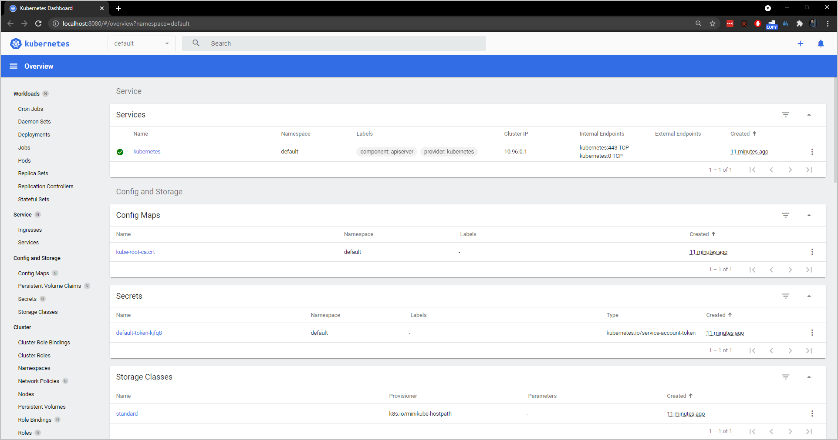

1. Stop port-forwarding by pressing Ctrl+C. Check whether do you still have connection or not.

$ kubectl port-forward --address 0.0.0.0 --namespace kubernetes-dashboard svc/kubernetes-dashboard 8080:80  
Forwarding from 0.0.0.0:8080 -> 9090  
Handling connection for 8080  
...  
Handling connection for 8080

1. You may leave or disable (delete) the dashboard service:

$ minikube addons disable dashboard  
 ▪ Using image kubernetesui/dashboard:v2.1.0  
 ▪ Using image kubernetesui/metrics-scraper:v1.0.4  
🌑 "The 'dashboard' addon is disabled